**Name:** B. Nageswar

**Reg-No**: 192372005

7. Construct a C program to implement a non-preemptive SJF algorithm.

### Aim:

To implement the **Shortest Job First (SJF)** scheduling algorithm using a non-preemptive approach in C.

### Algorithm:

1. **Input the Processes**:
   * Read the number of processes, burst times, and arrival times.
2. **Sort Processes**:
   * Sort the processes by their arrival times and burst times.
3. **Calculate Completion Times**:
   * Pick the process with the shortest burst time among the arrived processes.
   * Calculate completion, turnaround, and waiting times.
4. **Output the Results**:
   * Print process details along with turnaround and waiting times.
   * Compute average turnaround and waiting times.

### Procedure:

1. Input the number of processes and their burst and arrival times.
2. Sort the processes by arrival time. If two processes arrive at the same time, sort them by burst time.
3. Use a loop to simulate scheduling:
   * Select the process with the shortest burst time among the available processes.
   * Update its completion time and calculate turnaround and waiting times.
4. Output the schedule and calculate average times.

**Code:**

### #include <stdio.h>

### struct Process {

### int id, arrivalTime, burstTime, completionTime, turnAroundTime, waitingTime;

### };

### void sortByArrivalAndBurst(struct Process p[], int n) {

### for (int i = 0; i < n - 1; i++) {

### for (int j = 0; j < n - i - 1; j++) {

### if (p[j].arrivalTime > p[j + 1].arrivalTime ||

### (p[j].arrivalTime == p[j + 1].arrivalTime && p[j].burstTime > p[j + 1].burstTime)) {

### struct Process temp = p[j];

### p[j] = p[j + 1];

### p[j + 1] = temp;

### }

### }

### }

### }

### int main() {

### int n, currentTime = 0, completed = 0;

### printf("Enter the number of processes: ");

### scanf("%d", &n);

### struct Process p[n];

### for (int i = 0; i < n; i++) {

### p[i].id = i + 1;

### printf("Enter arrival time and burst time for process %d: ", i + 1);

### scanf("%d %d", &p[i].arrivalTime, &p[i].burstTime);

### }

### sortByArrivalAndBurst(p, n);

### 

### while (completed < n) {

### int idx = -1, minBurst = 1e9;

### for (int i = 0; i < n; i++) {

### if (p[i].arrivalTime <= currentTime && p[i].completionTime == 0 && p[i].burstTime < minBurst) {

### minBurst = p[i].burstTime;

### idx = i;

### }

### }

### if (idx != -1) {

### currentTime += p[idx].burstTime;

### p[idx].completionTime = currentTime;

### p[idx].turnAroundTime = p[idx].completionTime - p[idx].arrivalTime;

### p[idx].waitingTime = p[idx].turnAroundTime - p[idx].burstTime;

### completed++;

### } else {

### currentTime++;

### }

### }

### printf("\nProcess\tArrival\tBurst\tCompletion\tTurnaround\tWaiting\n");

### float avgTAT = 0, avgWT = 0;

### for (int i = 0; i < n; i++) {

### avgTAT += p[i].turnAroundTime;

### avgWT += p[i].waitingTime;

### printf("%d\t%d\t%d\t%d\t\t%d\t\t%d\n", p[i].id, p[i].arrivalTime, p[i].burstTime, p[i].completionTime, p[i].turnAroundTime, p[i].waitingTime);

### }

### printf("\nAverage Turnaround Time: %.2f\n", avgTAT / n);

### printf("Average Waiting Time: %.2f\n", avgWT / n);

### return 0;

### }

### Result:

When you run the program:

* Enter the number of processes and their arrival/burst times.
* The program outputs a table showing process details (arrival, burst, completion, turnaround, and waiting times).
* It also displays the **average turnaround time** and **average waiting time**.

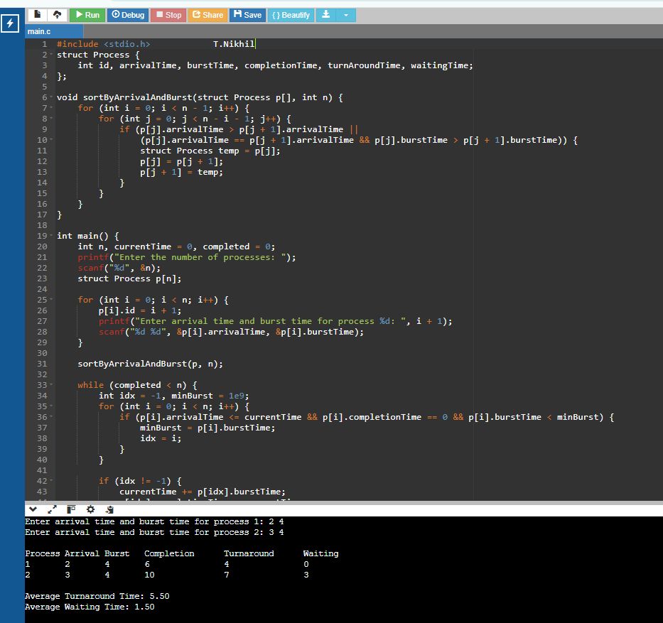**Output:**